Welcome!
Date
Name
Spouse
Address
City
State Zip _________
Email

Please Contact By
❑ Card  Phone  Visit

Telephone Best Time to Call
Home ______________
Work ______________

Guest: First Time Second Time
Are you a church member: yes no
Church
City, State

Circle Appropriate Age/Grade Group(s)
Preschool: Ages: B-1 2-3 4-5
Children: Grades: K 1 2 3 4 5 6
Youth: Grades: 7 8 9 10 11 12
Adults: Ages:18-29 30s 40s 50s 60s+

How did you learn about our church?
Newspaper Friend Yellow Pages Mail
Other

I am a guest of:

New in the Community? Yes No
Names & ages of children at home

Weekly Service & Activity Schedule

Aug 20, 2017
9:45 a.m. Sunday School
11:00 a.m. Worship Service
6:00 p.m. “Pentecost: God Changed His Address”

Week of Aug 20, 2017

Wednesday 6:30 pm……………..……….Meal/Bible Study
Thursday 10:00 am………………………Adult Fellowship
Friday 6:30 pm……………..……………..Men’s 42 Night
29………………………….………Make & Take Card Class
Sept
3……………………………….…New Commandment Kids
10…………………………………New Commandment Kids
10………………………………..…………..Business Meeting
10 – 17…………Week of Prayer – Mary Hill Davis Offering
14……………………………………..……..Adult Fellowship
17………………………………………..Merrell Baby Shower
Make & Take Card Class

Tuesday, Aug 29 @ 6 – 9 pm

The cost is $20 Contact Brenda Williams if you are interested 512-925-8572

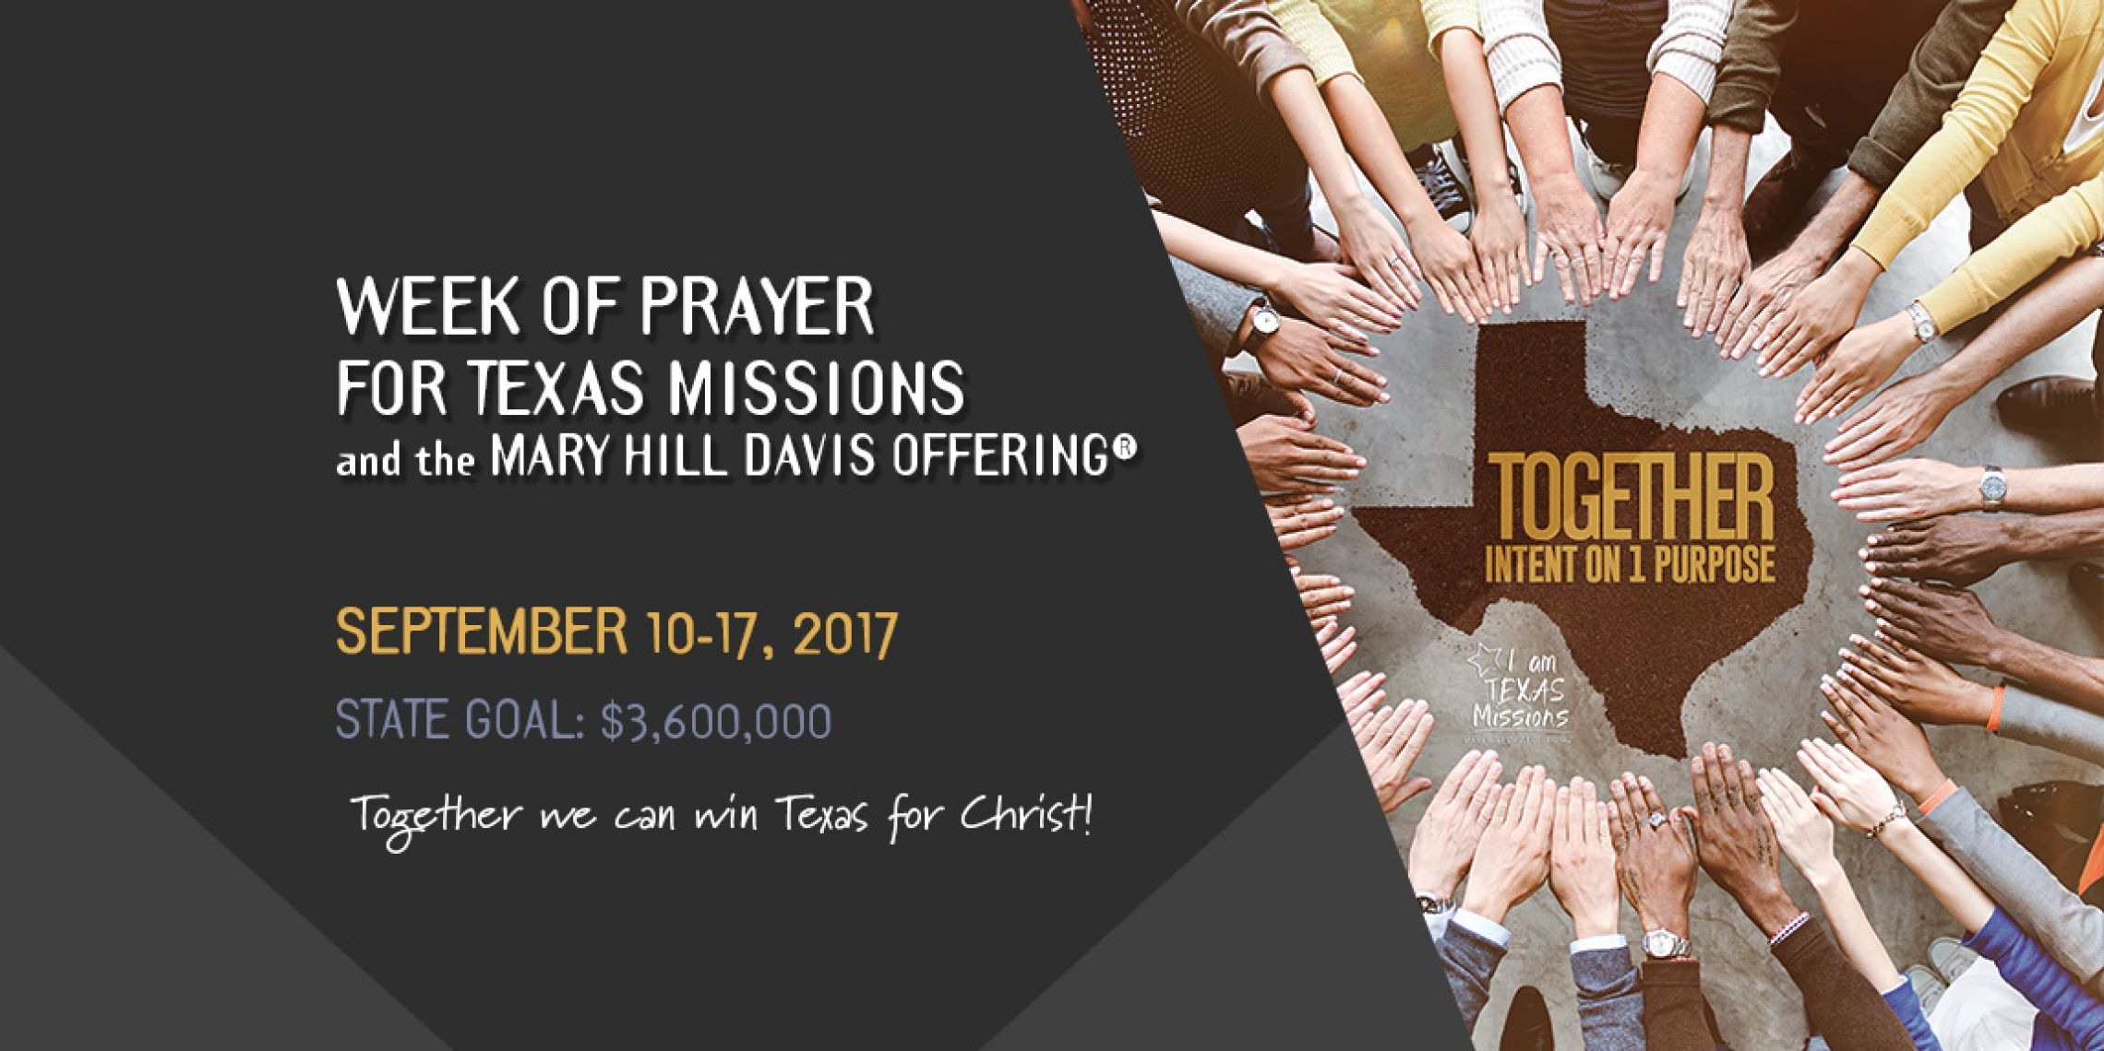

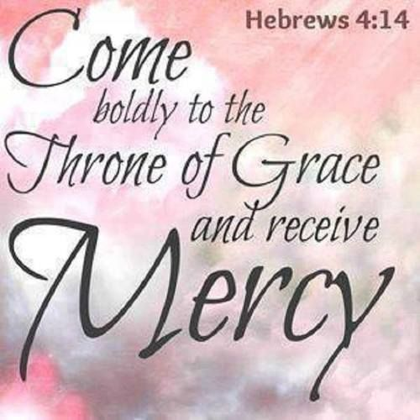

Knobbs Springs Baptist Church

Aug 20, 2017

Church Information:

KnobbsSpringsBC.com KnobbsSpringsBaptist@gmail.com

1662 CR 305, McDade, Texas 78650 512-273-2743

David Atwood, Pastor Cell 512-470-5098

Patti Radford, Office Manager Cell 512-968-7821

